**Community Development**

**Community development**: A **structured intervention** that **gives communities greater control** over the **conditions that affect their lives**. Community development aims to **address the issues of powerlessness and disadvantage**, so it **involves all members of society** and **empowers people** as part of a process of **social change**.

Community developers should **identify the values, needs and aspirations** of **residents, community members, businesses and other appropriate stakeholders** for the **benefit** of all involved.

Principles of community development:

1. **Sustainability** – The means of configuring communities and human activity so that **individuals are able to meet their needs** and **express their greatest potential** in the present while **planning and acting** for the ability to **maintain these ideals in the long-term**; increasing community **participation** in projects will **empower** individuals which leads to **increased sustainability**.
2. **Diversity** – The quality of being **different**; community development needs to **respect diversity** and **plan to be equitable to all**.
3. **Human rights** – The basic **rights and freedoms** to which **all humans are entitled**.
4. **Social justice** – Historical inequities in so far, as they affect current injustices, should be **corrected** until the actual inequities **no longer exist** or have been **perceptively negated**; the **redistribution of wealth, power and status** for the individual, community and societal **good**; it’s the **authority’s responsibility** to **ensure basic quality of life** for all its citizens.
5. **Addressing disadvantage** – The **responsibility of governments, policy makers, treasury and the UN**. Funds need to be directed toward projects or programs aimed at **reducing poverty and disadvantage**.
6. **Valuing local knowledge** – Culture skills resources; **all communities have already existing real and potential skills and resources**; health promoters can help people **use those skills** to both **develop and maintain their sustainability**.

**Empowerment**: Refers to increasing the **spiritual, political, social or economic strength** of **individuals and communities**. It often involves the empowered **developing confidence in their own capacities**.

Participation and empowerment:

* **Participation** is **needed to improve empowerment**.
* **Empowerment** is **needed to increase participation**.
* Both are **key factors** in sustainable **community development**.
* Empowerment occurs when people **realise** they can make a **contribution / solve problems** and they have a **right and responsibility** to do so.
* Empowerment enables people, organisations and communities to **gain control** over their lives, helping them to **move from powerless non-participants to active and effective citizens**.

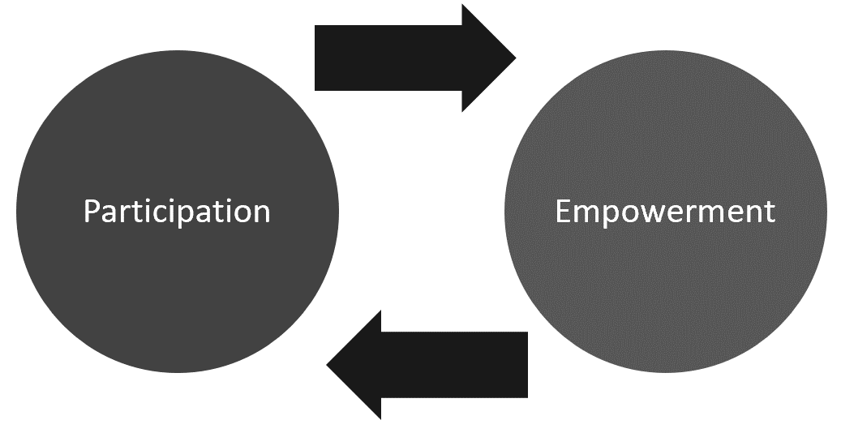

Individual vs community empowerment:

* **Individual empowerment** – Individuals’ ability to **make decisions and have control** over their personal life.
* **Community empowerment** – Involves individuals acting collectively to **gain greater influence and control over the determinants of health** and the **quality of life** in their community and is an important goal in community action for health.

The levels of participation outline how much input the community has in regard to decision-making and acting in the intervention effort.

Levels of participation:

1. **Information** – Informing people in the community what’s planned; the organisers of the intervention make all the decisions and carry out the intervention for the community.
2. **Consultation** – Asking for feedback about the interventions planned (consulting); usually done by offering a number of options and listening to the feedback; ultimate decision and carrying out is made by the intervention organisers.
3. **Deciding together** – Intervention organisers work with the people in the community to make the decision together about what will happen; may be done in the form of a vote or round table discussion.
4. **Acting together** – Organisers and community would decide what to do together and then put the plan into action together.
5. **Supporting community interest** – Community conducts their own project/intervention themselves with the support of external providers; the community have all the decision-making power and they put the plan into action.

**Jakarta Declaration**

Priorities for health promotion in the 21st century:

1. **Promote social responsibility for health**.

Decision-makers must be **committed to social responsibility**. This includes practices and policies that ensure they **avoid harming the health** of individuals, **protect the environment** and make sure **resources are sustainable**. Governments should **restrict the production and trading of harmful goods** as well as **discourage unhealthy marketing practices**. Employers should **safeguard people** both in the marketplace and workplace from illness and injury. Health impact assessment should be included.

1. **Increase investments for health development**.

There needs to be an **increase in investment** for the **development of resources** and the **health sector**. Investments for health need to **meet the needs of specific groups** within society.

1. **Consolidate and expand partnerships for health**.

**Partnerships** need to be developed **between government and broader society**. Partnerships that already exist should be **strengthened**. The **potential for new partnerships** to be developed must be **explored**. The existence of partnerships offers benefit for health through the **sharing of expertise, skills and resources**. Each partnership must be **based on ethical principles, mutual understanding and respect**.

1. **Increase community capacity and empower the individual**.

Good health promotion practices involve the community **improving both the ability of individuals to take action** and the **capacity of groups and organisations to influence the determinants of health**. Providing **practical education, leadership training and improved access to resources** can make improvements in community health. Empowering individuals requires **consistent, reliable access** by citizens to **decision-making processes**. Individuals also need to learn the **skills and knowledge essential to affect change** in their community.

1. **Secure an infrastructure for health promotion**.

To secure an infrastructure for health promotion, new methods for **funding** it locally, nationally and globally must be found. **Incentives** to pay for infrastructure for health should be developed. Organisations need to make sure **resources** are in place or planned to maximise health promotion. Training in and practice of **local leadership skills** should be encouraged in order to support health promotion activities. **Documentation of experiences in health promotion** through **research and project reporting** should be enhanced to **improve planning, implementation and evaluation** (PIE) of health promotion in the future.

**Social responsibility**: The **ethical and moral obligation** corporations, businesses, government and citizens have to larger society. People and groups of people have a **responsibility** to **act with the best interests of society**.

**Social Marketing**

**Social Marketing**: The use of **marketing techniques** to **promote health ideals**.

The aim is to improve society by **changing the beliefs, attitudes and values** of individuals, thereby **improving for the greater good**.

4 P’s of social marketing:

1. **Product** – The aim is to **change the perception of the consumers** about the problem and to convince them as to how important it is to **take action** against the problem e.g., condoms, medical examinations, breastfeeding, eating a healthy diet, environmental protection, etc.
2. **Price** – What the consumer **must do** in order to obtain the social marketing product. It’s the **goal** of the social marketer to ensure the **benefits are perceived as greater than their costs**. The perceptions of costs and benefits can be determined through research and used in positioning the product.
3. **Place** – The **way** that the **product reaches the consumer**. For tangible products: distribution system, retail outlets where it’s sold, places where it’s given out for free, etc. Intangible products: Decisions about the channels through which consumers are reached with information or training; doctor’s offices, shopping malls, mass media vehicles, in-home decisions, etc.
4. **Promotion** – The use of **advertising, public relations, promotions, media advocacy, personal selling and entertainment vehicles** (MAP PEP). The focus is on **creating and sustaining demand** for the product.

**Health Products & Services**

Factors influencing the use of health products and services:

1. **Media** – **Current affairs** and **product placement** can all influence the use of society of health products and services. Product manufacturers will use the media to **persuade** consumers to **use their product** and **increase consumer confidence**.
2. **Transport** – **Availability of public transport, parking and accessibility** can all influence the uptake of health services. Some individuals may be **excluded** from services as they **can’t afford** insurance cover or the associated fees. **Emergency service** will determine where they take the patient.
3. **Cost** – Consumers’ selection of products will be influenced by the **expense** of the product and whether they feel it’s “**quality for money**” and “**safe**” **regardless of price**.
4. **Consumer confidence** – Consumers have increased confidence in brands that are **true to their promises** – products that **deliver what they claim they will deliver**. Trusted brands develop an **emotional connection** between the consumer and brand.

Consumer confidence:

* Watching a medical procedure on a TV show will **increase confidence** in individuals to undergo the procedure themselves.
* It **demystifies the procedure** and makes the individual feel **better educated**.

**Product placement**: The use of specific products in a movie or TV program where the **manufacturer or retailer pay the media producer** as a form of advertising.

**Epidemiology**

**Epidemiology**: The study of the **distribution and determinants of health-related conditions** in specified populations, and the **application** of this study to **control health problems**.

Epidemiologists study the **distribution of frequencies and patterns of health events** within groups in a population.

Role of epidemiology:

* Information is used to **predict life expectancies** and **disease outbreaks**.
* **Advise and inform health promotion**.
* Provides the **basis for disease prevention** globally.

Epidemiologists:

1. Count cases of disease or injury.
2. Define the affected population.
3. Compare these rates with those found in other populations.
4. Make inferences regarding the **patterns** of disease to **determine whether a problem exists or is likely to exist in the future**.

Epidemiologists typically ask:

* Which individuals have experiences the event?
* When did they experience the event?
* Where are the individuals who have experienced the event?
* What environmental factors are associated with the event?

Epidemiological triangle:

Host  
Age, sex, immune status, previous disease…

Agent  
Bacteria, virus, chemical, radiation…

Environment  
Temperature, crowding, pollution, water…

Epidemiology

Measures of epidemiology:

|  |  |
| --- | --- |
| Mortality | Death.  Number of people who have **died** in a population (mortality rate).  A large number of people who **die due to a particular cause**. |
| Infant mortality | Death of babies and children.  Can be measured **under 1 year of age** or **under 5**.  Number of babies who die.  The **proportion of live births** who **don’t survive** in a population.  Doesn’t include stillbirths. |
| Morbidity | Sickness or illness.  Number of people sick or diseased in a population (morbidity rate).  Number of unhealthy people. |
| Life expectancy | How long on average a person is expected to live.  Specific to population of origin or ethnic group.  Number of years a population group is expected to live based on a statistical average of recent mortality rates. |
| Incidence of disease | Number of new cases of a disease or condition in a specific place and time period.  Gives an indication of the risk of contracting a disease.  Used to track disease outbreak and spread. |
| Prevalence of disease | Overall number of cases of a specific disease in a given population at a certain time.  Gives an indication of the overall size of the health problem, how widespread it is and how many people are affected. |
| Burden of disease | Health loss to society due to disease or injury that still remains after treatment, rehabilitation or prevention efforts.  One measure is disability-adjusted life years (DALYs) which is determined by subtracting from life expectancy the number of years of life lost due to premature death, and subtracting the years of healthy life lost due to disability and illness from disease or injury. |

**Preventive Strategies**

Screening involves the testing and monitoring of an otherwise healthy (non-symptomatic) population for sings of disease before they know they’re sick.

For screening to be effective there are a few conditions that must be met:

* Individuals must be able to recognise early warning signs and seek treatment or there must be a test that detects early signs and symptoms.
* There must be a test that confirms the specific disease.
* There must be a reliable treatment that’s successful in treating the disease early and stopping progression.

Immunisation:

* Immune system uses leukocytes to defend the body from antigens.
* Leukocytes make antibodies specific to each antigen.
* Antibodies destroy the antigens or help leukocytes destroy them.
* Vaccine contains a dead or weakened copy version of an antigen to help the body produce antigens to attack antigens.
* Body reacts to the vaccine by making antibodies.
* Body leaves memory cells to stay on the lookout for the antigen again.
* Memory cells notify the leukocytes quickly if they detect the germ and allow it to quickly make the antibodies and fight the disease.
* The germ can be fought and conquered quicker than the first time.

**Definitions**:

**Bacteria**: Single-celled microorganisms that can exist either as independent organisms or as parasites.

**Virus**: A microorganism that’s smaller than a bacterium that can’t grow or reproduce separate from a living cell; a virus invades living cells and uses their chemical machinery to keep itself alive and to replicate itself.

**Vaccine**: Any preparation intended to produce immunity to a disease by stimulating the production of antibodies.

**Vaccinate**: The act or practice of vaccinating; inoculation with vaccine.

**Immunisation**: The process of both getting the vaccine and becoming immune to the disease as a result of the vaccine.

**Immunity**: The ability of an organism to resist a particular infection or toxin by the action of specific antibodies or sensitised white blood cells.

**Natural immunity**: Immunity possessed by a group that’s present in an individual at birth prior to exposure to a pathogen or antigen.

**Health education**: Any combination of learning experiences designed to help individuals and communities improve their health, by increasing their knowledge or influencing their attitudes.

Health education aims to allow students to:

* Learn to access, evaluate and synthesise information, make decisions, seek help and take actions to protect, enhance and advocate for their own and others’ health, wellbeing, safety and physical activity.
* Develop and use personal and social skills and strategies to promote a sense of personal identity, wellbeing and to build and maintain positive relationships.
* Develop and use personal and social skills and strategies to promote a sense of personal identity, wellbeing and to build and maintain positive relationships.
* Analyse how personal, social, cultural, economic, technological and environmental factors shape understanding of and opportunities for health and physical activity locally, regionally and globally.

Levels of prevention:

1. **Primary prevention** – Aimed at the population as a whole and sets out to prevent disease before it occurs. This is the most cost-effective method as it avoids diagnosis, detection, treatment and recovery. Examples: Immunisation, health education, pasteurization of milk, washing hands, drinking clean water, etc.
2. **Secondary prevention** – Aims to locate symptoms early enough to be treated easily. The goal is to identify and treat infected people and catch the disease as early as possible to avoid advanced disease and symptoms. Example: Screening tests.
3. **Tertiary prevention** – Aims to minimize the impact of the sickness, restore function and prevent complications. Examples: Treatment, surgery, medication and recovery techniques.